**BCPR294 16S2 TEST #3B**

Name ___________________________________________________________ Mark ________ / 10

**Write a REST web service called reverse3.php to display the reverse of a string.**

The program should include a function to calculate the reversed string. This function takes as input a string and return the reversed string.

The output of the web service should be in JSON format and look like:

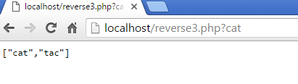

**MARKING GUIDE**

* define a class
* define an __constructor
* in a class define a property
* use 2 different visibilities
* in a class, define a method
* initialize an object/instance
* call an object method
* set up a web service in php $_SERVER
* returned JSON  json_encode
* callable from the brower as a REST web service